Food Diary Directions

Please record all food and drink for 24 hours before your assessment. It is easiest to record correctly if recording is done directly after a meal or snack.

1. Describe the food accurately and give brand names if possible. For example: margarine (Blue Bonnet soft tub) 1 teaspoon levels with knife.

2. Please record any foods that state they are fortified with additional vitamin D or calcium.

3. State whether fruits and vegetables are fresh, canned (water pack, heavy or light syrup), cooked or frozen.

4. Record the amount of food eaten by using household measures such as cups, teaspoons, tablespoons, or weigh the food. For example: Whole milk ½ cup or 4 ounces (oz) 2% cottage cheese or 4 level tablespoons

5. For meat every oz is about the size of a match box. 3 oz is about the size of a deck of cards. Keep in mind the bone takes up space. For example: Broiled pork chop with bone = 3 ounces, bone weight is 1 ounce, so total weight of pork chop is 2 ounces.

6. Describe sandwiches in detail.

For example: Bologna sandwich: 2 slices of whole wheat bread, 1 slice (1 ounce) bologna, 1 level tablespoon Kraft Mayonnaise (lite or regular), 1 lettuce leaf, 1 slice (1 ounce )Processed cheese (Kraft)

7. Be sure to record amounts of additional foods served with cereals or desserts, etc.

For example: Cereal: ½ cup Rice Krispies (Kellogs), ¼ cup milk 2%, 2 level tablespoons Brown Sugar

8. Include how the food is prepared especially for meats, fish, poultry, eggs, and vegetables. Methods of preparation include boiling, roasting, baking, broiling, frying or steaming. When frying, be sure to mention the type of fat or oil used.

9. If eating out, describe food item well. Please record the name of popular fast food restaurants as we have nutrition information for all foods

10. Please include any vitamins and minerals you consume.

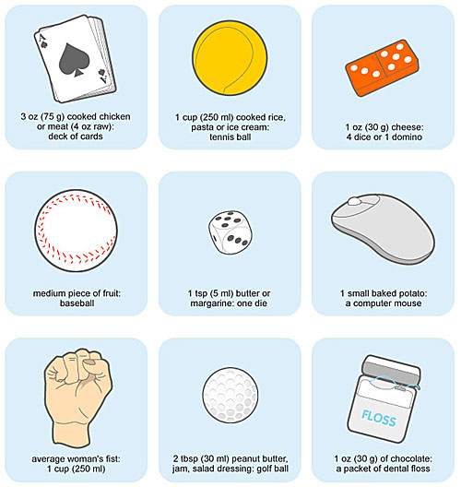

http://remakemyplate.com/resources-tips-and-tools/size-it-up-portion-sizes/

Food Diary

Date: Example

|  |  |  |  |  |  |
| --- | --- | --- | --- | --- | --- |
| Time | Food/drink eaten | How hungry before meal  (1-5, 1=very hungry, 2=hungry, 3=neutral, 4=satisfied, 5= full) | Mood before meal | How hungry after meal  (1-5, 1=very hungry, 2=hungry, 3=neutral, 4=satisfied, 5= full) | Mood after meal |
| *8:15am* | *1 cup cereal, 1 cup 1% milk, 1 large banana, 1 cup coffee with 1 tsp sugar* | *1* | *tired* | *4* | *Slightly awake* |
| *10:30* | *Granola bar* | *3* | *bored* | *4* | *Slightly happy* |
| *12:30* | *Sandwich- 2 slice whole wheat bread, slice of American cheese, 2oz of lean ham deli meat, lettuce, tomato, 2 tbsp mayo*  *1 oz Doritos chips*  *1 small cookie*  *½ cup apple sauce*  *8 oz water* | *2* | *annoyed* | *5* | *happy* |
| *2:00* | *1 fun size snickers bar, 8 oz water* | *3* | *happy* | *3* | *happy* |
| *5:00* | *16 oz Gatorade* | *3* | *Bored* | *4* | *Bored* |
| *6:00* | *3 oz chicken breast, 1 cup mash potatoes, 1 tsp butter, ½ cup canned green beans, ½ cup corn, 1 cup apple juice* | *2* | *tired* | *5* | *neutral* |
| *7:00* | *6oz cup of flavored Greek yogurt* | *3* | *Happy* | *4* | *happy* |
|  |  |  |  |  |  |
|  |  |  |  |  |  |
|  |  |  |  |  |  |
|  |  |  |  |  |  |
|  |  |  |  |  |  |
| Time | Physical Activity | How long | Intensity |  | |
| *2:30* | *Ballet- Advance level* | *1hr 30 min* | *low* |
| *4:30* | *Gym- weights lower body and back* | *45 min* | *high* |

Date:

|  |  |  |  |  |  |
| --- | --- | --- | --- | --- | --- |
| Time | Food/drink eaten | How hungry before meal | Mood before meal | How hungry after meal | Mood after meal |
|  |  |  |  |  |  |
|  |  |  |  |  |  |
|  |  |  |  |  |  |
|  |  |  |  |  |  |
|  |  |  |  |  |  |
|  |  |  |  |  |  |
|  |  |  |  |  |  |
|  |  |  |  |  |  |
|  |  |  |  |  |  |
|  |  |  |  |  |  |
|  |  |  |  |  |  |
|  |  |  |  |  |  |
|  |  |  |  |  |  |
|  |  |  |  |  |  |
|  |  |  |  |  |  |
|  |  |  |  |  |  |
| Time | Physical Activity | How long | Intensity |  | |
|  |  |  |  |
|  |  |  |  |